**Create Cloudant DB**

**Deep Learning Fundus Image Analysis for Early Detection of Diabetic Retinopathy**

Team ID: PNT2022TMID20647

* Create Service Instance
* Creating Service Credentials

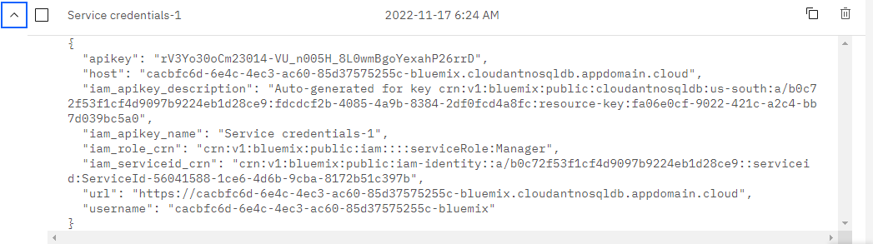

* Launch Cloudant DB

* Create Database

